|  |  |
| --- | --- |
| **DOCUMENT** | **FLOW CHART DIAGRAM** |
| **AUTHOR** | **AKANKSHA SRIVASTAVA** |
| **VERSION** | **1** |
| **DATE** | **18-JULY-2020** |

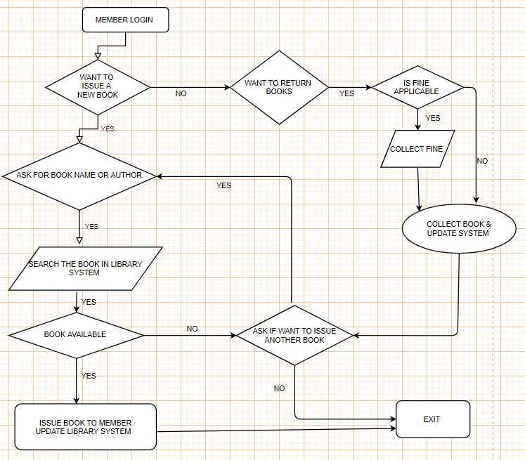

FLOW CHART DIAGRAM: -